**SENATE DECISION: 13/12/2023**

**FENERBAHÇE UNIVERSITY**

**CODES OF PRACTICE REGARDING COLLECTION AND STORAGE OF MEASUREMENT AND EVALUATION MATERIALS**

**PART ONE**

**Purpose, Scope, Basis and Definitions**

**Purpose**

**ARTICLE 1 –** (1) The purpose of these codes of practice is to regulate the procedures and principles regarding the collection and storage of measurement and evaluation materials in all educational activities carried out at Fenerbahçe University.

**Scope**

**ARTICLE 2 –** (1) It covers the provisions regarding the collection and storage of measurement and evaluation materials in all educational activities carried out at Fenerbahçe University.

**Basis**

**ARTICLE 3 –** (1) These codes of practice have been prepared based on the Fenerbahçe University Associate and Undergraduate Education and Training Directive, Fenerbahçe University Postgraduate Education and Training Directive and Article 14 of the Higher Education Law No. 2547.

**Definitions**

**ARTICLE 4 –** (1) Unit: Faculties, colleges and vocational schools within Fenerbahçe University and centers and departments that carry out education and training programs under the rectorate.

1. Course design: Academically qualified expression that includes the purpose, goal, outputs/gains, measurement and evaluation method, syllabus and bibliography of a course.
2. Instructor: A faculty member or lecturer who teaches courses, as defined in the Higher Education Law No. 2547.
3. Measurement and evaluation activities: All measurement and evaluation activities carried out with or without supervision regarding all courses taught in the units.
4. University: Fenerbahçe University

**PART TWO**

**Principles Regarding Measurement and Evaluation Materials**

# Responsibilities of Units and Instructors

**ARTICLE 5 –** (1) The instructor defines the measurement and evaluation method, along with other requirements, within the scope of the academic information package in the student operating system (OİS) for each course assigned to him/her in each semester.

(2) The instructor, for the activities/exams defined in the measurement and evaluation method for each course assigned to him/her at the end of each semester, and also for the measurement and evaluation activities/exams carried out at the unit level,

1. All materials of the graded basic activities/exams such as quizzes, mid-term exams, final exams, exemption exams, make-up exams, assignments, presentations and additional exams, three-course exams, special talent exams, etc. belonging to the relevant measurement and evaluations will be stored in the exam envelope, materials of a size/scale that will not fit into the exam envelope (exam papers, assignments, presentations, projects, models, etc.) will be stored in the exam envelope annex, and materials that cannot be added to the exam envelope will be digitally recorded and stored in Fenerbahçe University's cloud storage area. Exam envelopes are delivered to the relevant unit secretariat by filling in the information on the exam envelope and marking the fields, within 15 days at the latest after the end of the deadline for objecting to grades at the end of the semester. The materials in the digital environment will be saved in the Fenerbahçe University cloud storage area with the folder and file naming format in the annex of these codes of practice and will be shared with the relevant unit secretariat within 15 days at the latest after the end of the objection period to the grades at the end of the semester.
2. All materials of the graded basic activities/exams such as quizzes, mid-term exams, final exams, exemption exams, make-up exams, assignments, presentations and additional exams, three-course exams, special talent exams, etc., which are carried out entirely in a digital environment, will be saved in the Fenerbahçe University cloud storage area with the folder and file naming format provided in the annex of these codes of practice and shared with the relevant unit secretariat within 15 days at the latest after the end of the objection period to the grades at the end of the semester.
3. The unit secretariat receives the relevant exam envelope and/or digital materials and the materials of the measurement and evaluations carried out entirely in digital media from the responsible instructor, after checking their compliance with the order specified in these codes of practice, by saving them in Fenerbahçe University's cloud storage area.
4. The following items must be included in the submitted exam envelope:
5. Weekly syllabus of the course initialed by the instructor via OIS,
6. Course absence report signed by the instructor via OIS,
7. A sample of the exam questions,

ç) Answer keys for exams,

1. Answer sheets of students' exams,
2. Exam minutes signed by the instructor responsible for the course and the exam invigilator(s),
3. The grade evaluation list signed by the instructor via OIS.

(5) The folder delivered digitally should contain the following:

1. Weekly syllabus of the course recorded by the instructor via OIS,
2. The grade evaluation list recorded by the instructor via OIS,
3. Absence report recorded by the instructor via OIS,

ç) A sample of exam questions,

1. There must be a file and/or folder containing the students' answers, saved through the online education management system used at the University.
2. For measurement and evaluation activities uploaded to digital media, the grade evaluation list, weekly course syllabus, absence report and exam minutes are delivered to the relevant unit secretariat in the exam envelope, signed by the instructor.

(6) If the instructor leaves the course he/she is responsible for before the end of the semester, the completed measurement and evaluation materials for the relevant course must be delivered to the relevant unit secretariat and/or shared digitally within the exam envelope and/or recorded digitally.

1. Missing exam envelopes and/or digital materials will not be accepted by the units until the deficiencies are corrected.
2. Unit secretariats deliver the exam envelopes and/or digital materials collected in the unit to the University archives officer within 30 days at the latest after the completion of all measurement and evaluation activities/exams for the relevant semester.
3. Exams are kept for 2 years, exam results and grade and success charts are kept for 10 years.
4. In units related to the Turkish Language Teaching Application and Research Center, Foreign Languages ​​Department and similar educational programs, exam envelopes and/or digital materials are delivered to the unit manager by the responsible instructors on the dates previously determined by the relevant unit manager and are kept under the responsibility of the unit manager. The unit manager delivers the exam envelopes and/or digital materials collected in the unit to the University archives officer within 30 days at the latest after the completion of all measurement and evaluation activities/exams for the relevant semester.
5. When it is necessary to collect the exam envelopes and/or digital materials delivered to the university archive, the relevant unit secretaries or unit managers collect the relevant exam envelope and/or digital materials with the delivery report. After the necessary procedures, it is delivered to the University archives responsible with a delivery report.
6. Measurement and evaluation materials collected in digital media are stored by the archive responsible by transferring them to an external disk or DVD.

**PART THREE   
Effectiveness and Enforcement**

**Effectiveness**

**ARTICLE 6 –** (1) These codes of practice shall enter into force from the date of their approval by the Senate.

**Enforcement**

**ARTICLE 7 –** (1) The Rector of Fenerbahçe University shall execute the provisions of these codes of practice.

Attachment

## FENERBAHÇE UNIVERSITY Information Note on the Collection and Storage of Measurement and Evaluation Materials for the 2023 – 2024 Academic Year

The academic unit manager is responsible for collecting and storing measurement and evaluation materials.

The task flow of the responsible instructor of the course, the academic unit secretary, the Information Technologies Directorate and the Distance Education Application and Research Center (UZEM) regarding the collection and storage of measurement and evaluation materials is shown in *Figure 1* and *Figure 2*.

For folder and file naming to be created according to the order specified in the codes of practice for measurement and evaluation materials to be collected and stored in digital environment, *see Figure 3, Figure 4, Figure 5, Figure 6.*

**Duties of academic unit secretaries:**

1. Opening folders named as “NAME-SURNAME” of the instructors in the folder/folders shared by UZEM in the Fenerbahçe University cloud storage area,
2. Sharing the folders opened under the names of the instructors with the research assistants of the departments and making the necessary announcements,
3. Carrying out the process of collecting measurement and evaluation materials in the cloud storage area within the date range specified by UZEM,
4. Checking the compliance of the materials collected in the cloud storage area with the qualifications specified in the "Fenerbahçe University Application Principles Regarding the Collection and Storage of Measurement and Evaluation Materials",
5. In case there are files and contents that need to be edited, providing feedback to instructors on the necessary arrangements and carrying out the process of completing the files according to the scope and content specified in the codes of practice,
6. Carrying out checks following the feedback and editing processes,
7. After the checks are completed, removal of folder sharing with instructors in cloud storage,
8. Upon completion of the process, notification to UZEM that archives within the academic unit are created in the cloud storage area.

* In the department folders where measurement and evaluation materials will be stored, the instructor of each course, the department and faculty information to which the instructor is affiliated should be listed, matched with the department curriculum.

* The folder for permanent instructors assigned from different units or instructors who are not on the University staff and work in more than one department should be created within the main department/program folder to which the faculty member is affiliated.

**Figure 1.**Task flow chart 1 (academic unit level chart)

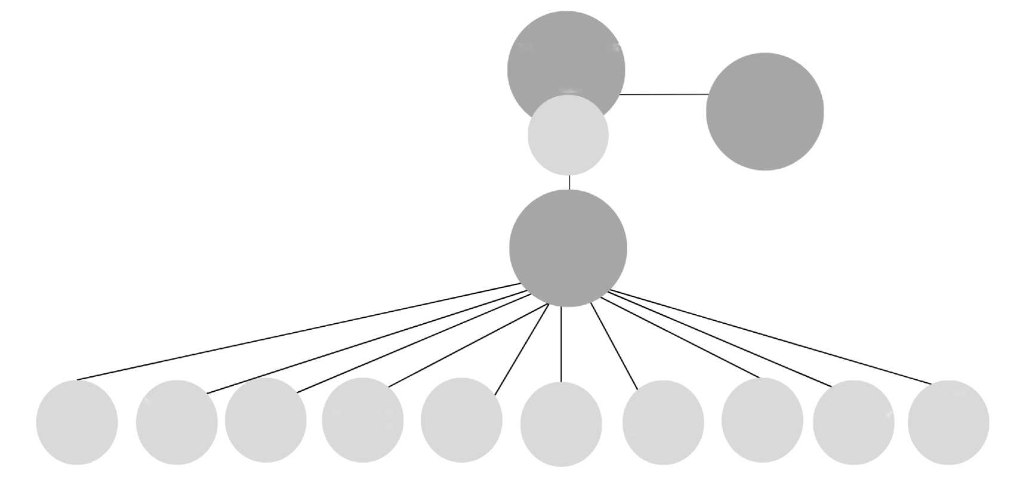

DISTANCE EDUCATION APPLICATION AND RESEARCH CENTER (UZEM)

INFORMATION TECHNOLOGIES DIRECTORATE

ACADEMIC UNITS

ACADEMIC UNIT SECRETARY

Turkish Teaching Application and Research Center

Faculty of Pharmacy

Faculty of Economics, Administrative and Social Sciences

Faculty of Communication

Faculty of Engineering and Architecture

Faculty of Health Sciences

Faculty of Sports Sciences

Vocational School of Health Services

Institute of Graduate Studies

Department of Foreign Languages

**Figure 2.** Task flow chart 2 (sample chart at course level)

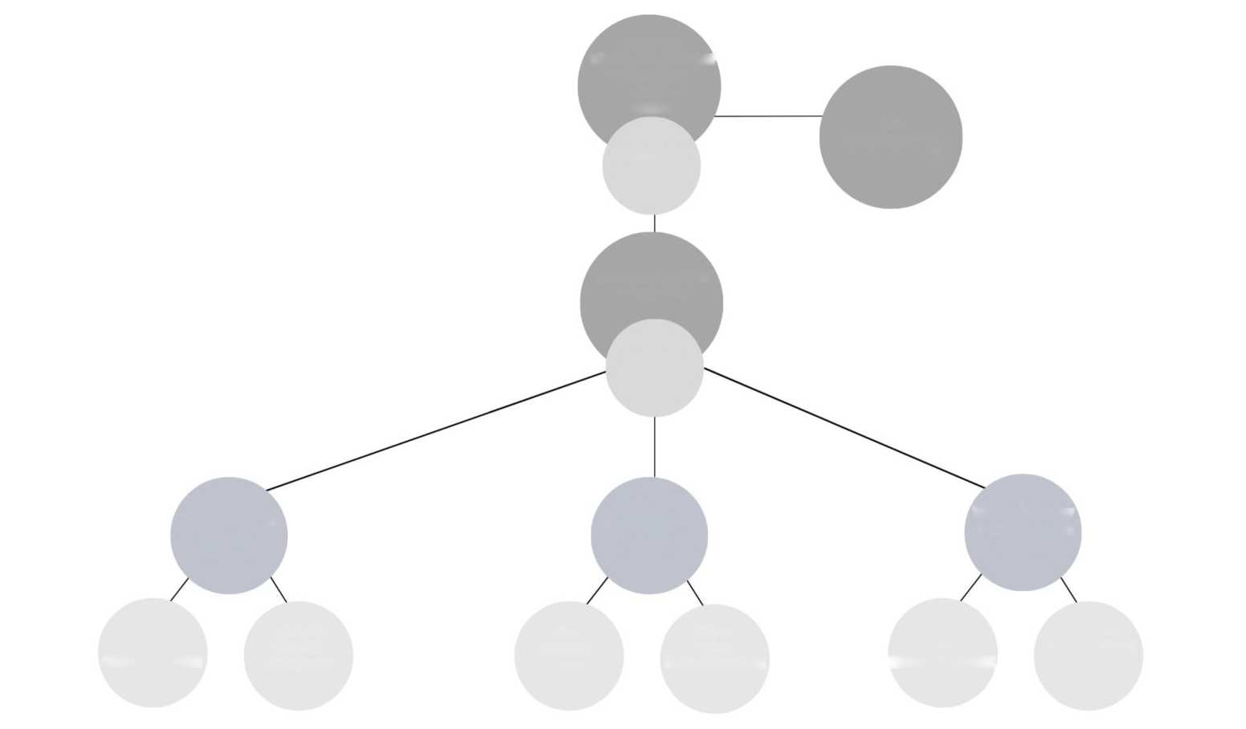

DISTANCE EDUCATION APPLICATION AND RESEARCH CENTER (UZEM)

INFORMATION TECHNOLOGIES DIRECTORATE

ACADEMIC UNITS

ACADEMIC UNIT SECRETARY

FACULTY OF COMMUNICATION

Department of Radio, Television and Cinema

Department of Public Relations and Advertising

Department of New Media and Communication

NEMC102 COMMUNICATION THEORIES

RT113 COMMUNICATION ETHICS

RTC115

BASIC PHOTOGRAPHY

PRA103

MEDIA

LITERACY

PRA105 ADVERTISING

NEMC252

NEW MEDIA AND DEMOCRACY

**Steps regarding the process of preparing instructors' measurement and evaluation materials in digital environment:**

1. The folders that the responsible instructor will upload to the cloud storage area should be prepared for each course and named in the format "ACADEMIC UNIT NAME ABBREVIATION-DEPARTMENT/PROGRAM NAME-SEMESTER-COURSE CODE-COURSE NAME". *(See Figure 4)*

Abbreviations;

For Faculties, Colleges, Institutes and Centers, it should be made using the first letters of the unit names, using capital letters and not containing any Turkish characters.

In units with the same initials, the abbreviation should be formed with the first two letters of the first word and the first letters of the other words.

* Faculty of Pharmacy 🡺 EF
* Faculty of Economics, Administrative and Social Sciences 🡺 IISBF
* Faculty of Communication 🡺 IF
* Faculty of Engineering and Architecture 🡺 MMF
* Faculty of Health Sciences 🡺 SBF
* Faculty of Sports Sciences 🡺 SPBF
* Vocational School of Health Services 🡺 SHMYO
* Institute of Postgraduate Education 🡺 LEE
* Department of Foreign Languages 🡺 YDB
* Turkish Language Teaching Application and Research Center 🡺 TOMER

1. In the course folder *(See Figure 5)*;

* There must be a "GRADE-EVALUATION-LIST" to be taken at the end of the semester through OIS and it must be named as specified,
* The syllabus (Report) to be received via OIS must be found and named in the format "SYLLABUS",
* There must be an “ABSENCE-REPORT” to be obtained from OIS and it must be named as specified.

* In addition, the Grade Evaluation List, Syllabus, Absence Report and Exam Minutes must be signed and submitted to the relevant unit secretariat in the exam envelope.

In addition to these, for all activities and exams that are graded regarding the measurement and evaluation of the course;

* + For mid-term exams, folders should be created for these exams with the name "MID-TERM" (if there is more than one mid-term exam, "MID-TERM-1", "MID-TERM-2" ...),
  + A folder named “FINAL” should be created for the final exam,
  + For make-up exams, folders should be created with the names “MIDTERM-MAKEUP” or “FINAL-MAKEUP”, depending on the exam to which they belong,
  + For assignments, folders named “ASSIGNMENT” (if there is more than one assignment, “ASSIGNMENT-1”, “ASSIGNMENT-2”, etc.) should be created,
  + For quizzes, folders should be created with the name "QUIZ" (or "QUIZ-1", "QUIZ-2", etc. if there is more than one),
  + Folders should also be created for the digital materials of all other basic measurement and evaluation activities/exams (additional exams, three-course exams, special talent exams, etc.) that are graded and not mentioned above, and they should be named in accordance with the specified format requirements. Within each exam folder created, according to the relevant exam, *(See Figure 6)*;
  + A sample of the exam questions should be named as “MIDTERM-EXAM-QUESTIONS”, “FINAL-EXAM-QUESTIONS”, “QUIZ-QUESTIONS” in accordance with the exam name,
  + The answer keys for the exams should be named as “MIDTERM-ANSWER-KEY”, “FINAL-ANSWER-KEY”, “QUIZ-ANSWER-KEY” in accordance with the name of the exam,
  + The excel (xls, xlsx) format file taken from the Blackboard Platform and containing all students' answers should be named as "COURSE CODE-COURSE NAME-EXAM NAME-STUDENT-ANSWERS" and should be attached as an excel file. The files uploaded by students within the scope of the exam should be named as “STUDENT NAME-SURNAME-1” with the question number next to it, and if more than one file is uploaded by the same student for a question, they should be named as “STUDENT NAME-SURNAME-1A”, “STUDENT NAME-SURNAME-1B” with a letter added after the question number.

Following these procedures, the folder(s) belonging to the course(s) taught by the responsible instructor must be converted to "zip" (compressed folder) format.

The instructor must log in to the cloud storage area where the folder shared with him/her is located with his/her username and password, and upload the “zip” file(s) he/she has prepared for each course he/she teaches as separate file(s) to the folder named with his/her name in the cloud storage area.

** In the case that the students' answers cannot be displayed completely in the excel (xls, xlsx) format file taken from the Blackboard platform and containing all the students' answers (e.g. mathematical formulas etc.), the files related to the students' answers can be saved as documents (doc, docx, pdf), visuals (jpeg, png) or in formats specific to the program used in the measurement and evaluation. A sample of the exam questions and answer keys can also be saved in doc, docx, xls, xlsx, pdf, jpeg or png formats.

** Turkish characters (ç, ğ, ı, ö, ş, ü) should not be used in folder and file naming.

** Spaces should not be used when naming. Care should be taken to use hyphens and capital letters specified in naming formats.

**Figure 3.**Folder contents

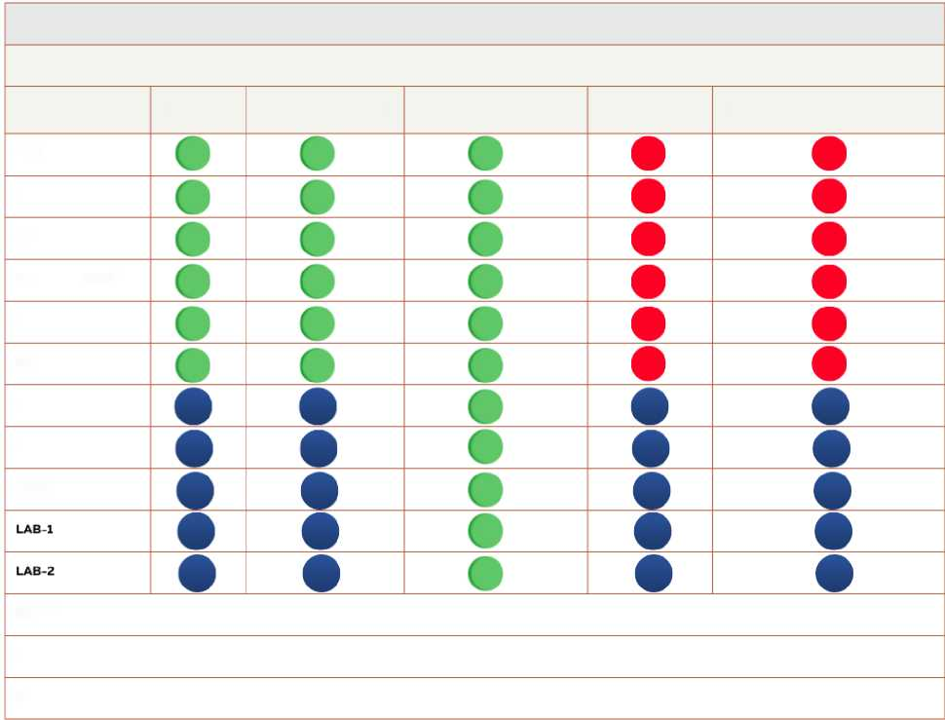

INSTRUCTOR NAME-SURNAME

IF-RADIO-TELEVISION-AND-CINEMA-1-SEMESTER-RTC 113-COMMUNICATION-ETHICS

QUESTIONS

ANSWER-KEY

STUDENT-ANSWERS

SUBJECT

EVALUATION-CRITERIA

MIDTERM

MIDTERM-MAKEUP

FINAL

FINAL-MAKEUP

QUIZ-1

QUIZ-2

ASSIGNMENT-1

ASSIGNMENT-2

ASSIGNMENT-3

SYLLABUS

GRADING-EVALUATION-LIST

ABSENCE-REPORT

 It specifies what should be in the relevant folder.

 It specifies what does not need to be in the relevant folder.

 What should be included in the relevant folder varies depending on the content of the measurement and evaluation.

Example: If a study on a topic is requested within the scope of “ASSIGNMENT” (or LAB), the SUBJECT and EVALUATION-CRITERIA must be included. If it is a measurement and evaluation that includes questions and answers, there should be QUESTIONS and ANSWER KEY in the “ASSIGNMENT” (or LAB) folder. STUDENT-ANSWERS must be present in both types.

**Figure 4.**First level - Folder (main folder)



**Figure 5.**Second level - Folders and Files (intermediate folders and files)

metin, ekran görüntüsü, yazılım, multimedya yazılımı içeren bir resim

Açıklama otomatik olarak oluşturuldu

**Figure 6.**Third level - Files (subfiles)

metin, ekran görüntüsü, yazı tipi, yazılım içeren bir resim

Açıklama otomatik olarak oluşturuldu